1) Top plot (Input Signal u): A periodic signal varying between ~15 and 65, used to excite the system.

* Bottom plot (Output Signal y): A delayed, amplified, and smooth response (up to ~600), showing the system’s dynamic behavior.

This indicates a linear dynamic system with memory (e.g., inertia or lag), suitable for modeling using N4SID.

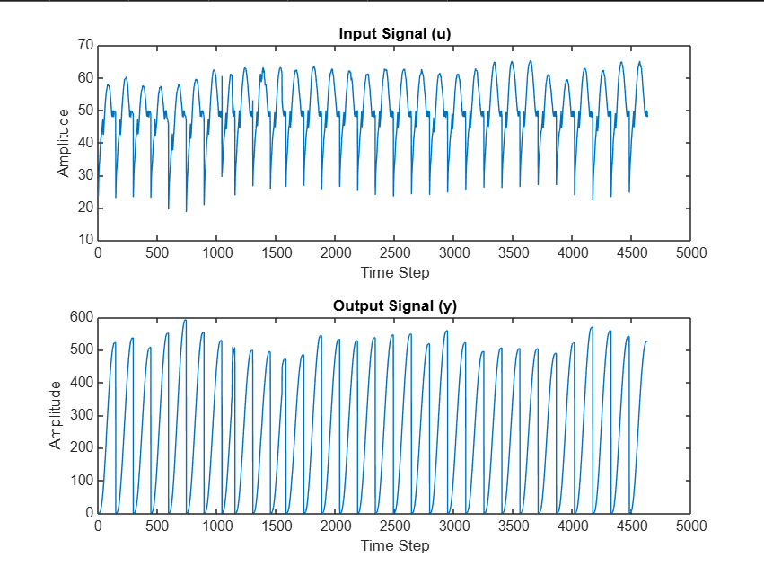

2) Top plot (y1 – Output):

* + The output signal shows smooth, oscillatory behavior with a peak around 550.
  + It reflects how the system reacts over time — delayed and amplified compared to the input.
* Bottom plot (u1 – Input):
  + This is the system's input signal, more abrupt and jagged in nature, varying between ~20 to 65.
  + It excites the system with enough variation for proper model identification.

**Key Insight:**

The system shows dynamic, possibly resonant behavior — the output smoothly follows the input with some lag and amplification, indicating a linear time-invariant (LTI) system with internal dynamics.

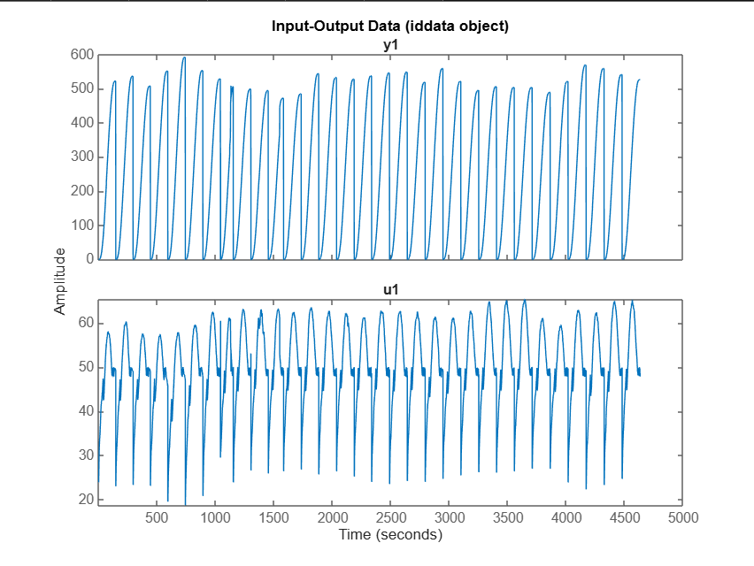

3) Top (Magnitude): System amplifies low frequencies (20–35 dB), but response is noisy at high frequencies.

* Bottom (Phase): Phase shift is smooth at low frequencies, erratic at high frequencies due to noise.

Conclusion: The system is reliable at low frequencies; high-frequency data is noisy and less trustworthy.

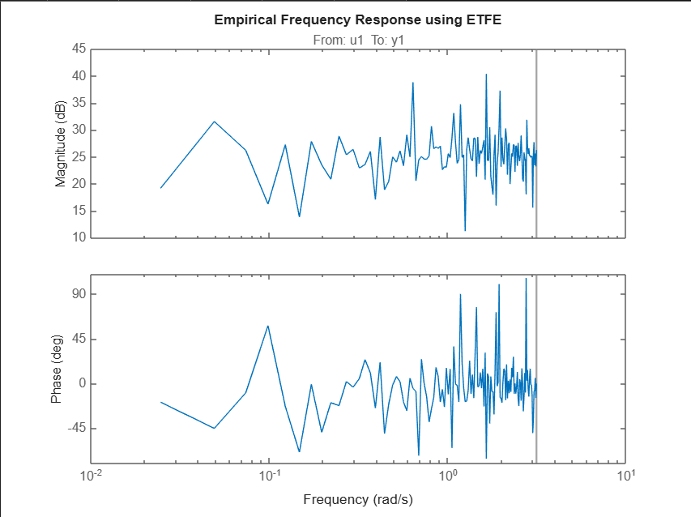

4) * The impulse response has extremely large negative values (~10²⁴).

* This indicates a numerical instability or modeling error in the identified N4SID model.

* The response is not physically meaningful and suggests that the model may be poorly conditioned or overfitted.

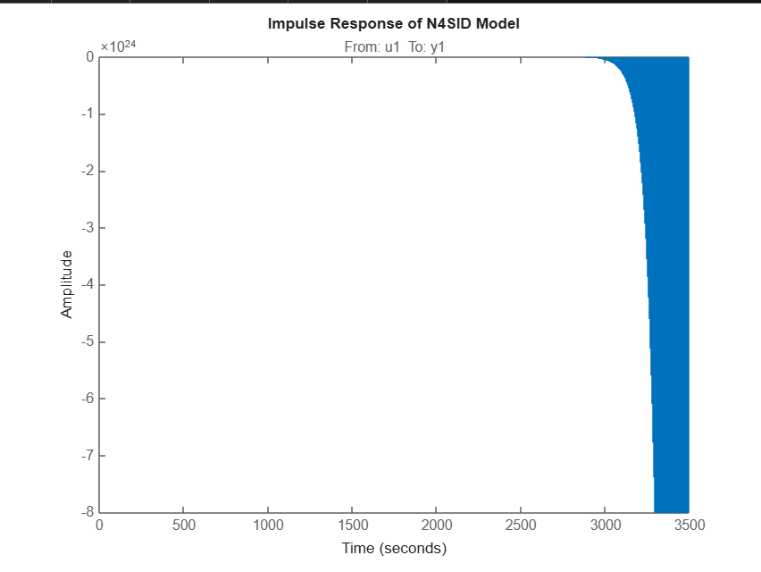

5) The model fit is extremely poor — we get a value of minus 3.455 times 10 to the power of 23 percent, which clearly indicates the model is unstable and not reliable.

This usually happens when the model contains unstable poles, or when the model order is not appropriate. It could also be due to unprocessed data or a mismatch in sampling time.

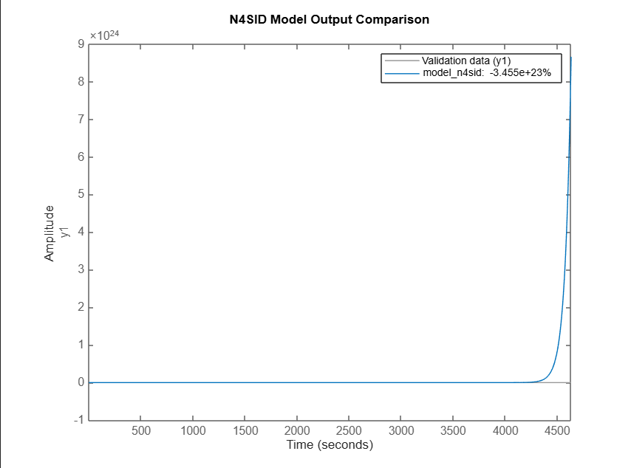

6) This figure shows residual analysis, which evaluates how well the model captures the system dynamics.

* Left plot (AutoCorr): Autocorrelation of the residuals
* Right plot (XCorr): Cross-correlation between residuals and input

**Interpretation:**

* Autocorrelation (left):  
  There's a large spike at lag 0, and the other values are outside the confidence bounds (shaded area), indicating residuals are not white noise.  
  → The model hasn’t fully captured the system dynamics.
* Cross-correlation (right):  
  The residuals and input are correlated, which should not happen in a good model.  
  → Suggests the model output is still influenced by the input, meaning unmodeled dynamics remain.
* 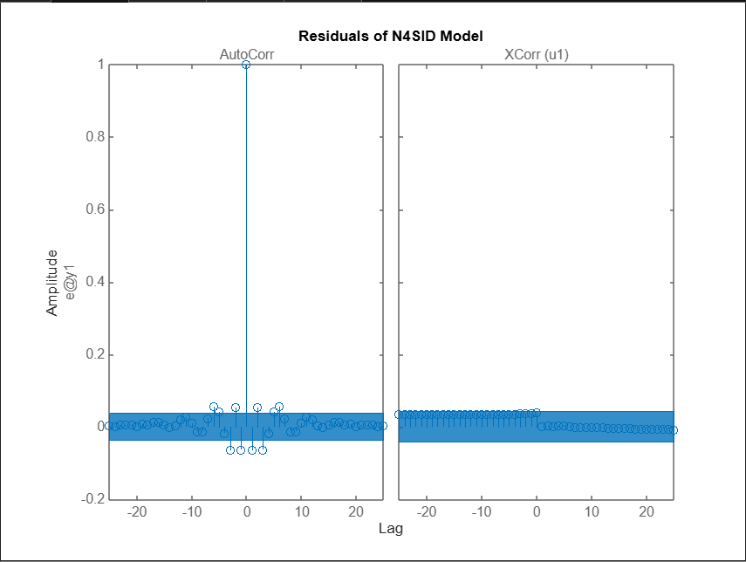7) This plot shows the poles (×) and zeros (○) of the identified N4SID model in the z-domain.
* The dotted unit circle represents the stability boundary.
* Stable systems have all poles inside the unit circle.

**Observation**

* One or more poles lie on or very close to the unit circle (some possibly outside).
* This indicates the system is unstable.
* Therefore, the current model is not reliable for control or prediction

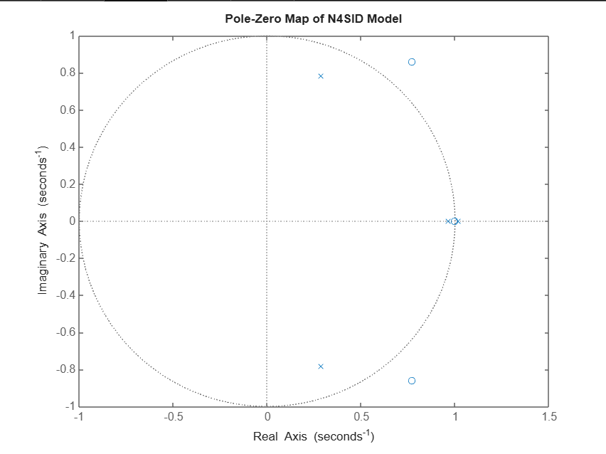

8) The plot shows the output response (y1) to a unit step input (u1) over time.

* The response rapidly diverges to extremely large values (×10²⁵), which is physically unrealistic.
* This indicates the model is unstable, confirming earlier findings from the pole-zero map.

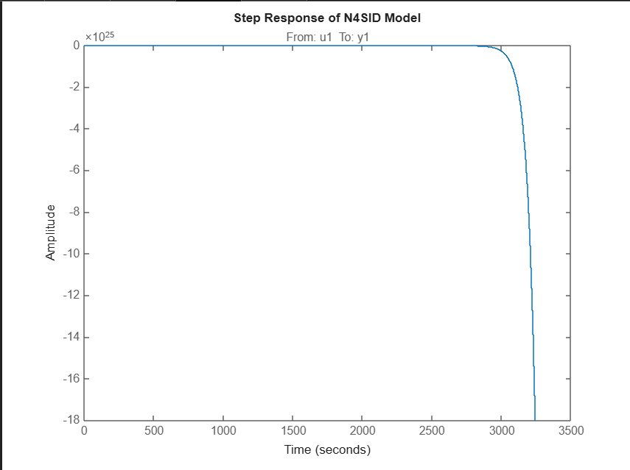

9) * The plot displays the magnitude of singular values in descending order.

* A rapid drop from the 1st to the 2nd singular value indicates that only one or two modes dominate the system dynamics.

* The very small 4th singular value suggests that the system may be numerically ill-conditioned or close to singular, which can cause instability or poor model performance.

